**Activity I: Create a List of Directories of your Computer**

Generate a list of all one-level and two-level directories in your computer.

All of the directories are under /.

Here, we refer to:

/Directory-Name1

as a one-level directory. For example, /home is a one-level directory.

We refer to:

/Directory-Name1/Directory-Name2

as a two-level directory. For example, /home/pi is a two-level directory.

For example, your list will contain:

/home

/home/pi

**References**

??? Add how to open the command prompt.

To determine whether we have a file or a directory, you can use the ls -al command.

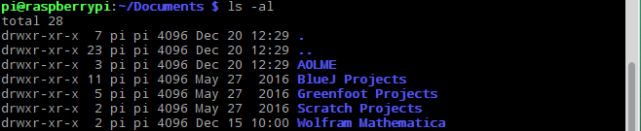

Look at the first letter for each file:

If it is a “d”, then it is a directory.

If it is a “-”, then it is a file.

In the example above, they are all directories.

The name of the file or directory appears at the end.

We have some special directory names:

/ refers to the root directory.

. refers to the current directory.

.. refers to the previous directory.

**Table I. Reference commands.**

|  |  |  |
| --- | --- | --- |
| **Command** | **Description** | **Examples** |
| pwd | Print Working Directory. Prints the current directory name. | >pwd  /home/pi |
| ls | Lists the files and directories in the current directory. | >ls  pi readme.txt |
| ls -al | Prints detailed information for each local file and directory. See detailed example. | >ls  drwx … pi  -drwx … readme.txt |
| cd name | Change Directory to name.  / refers to the root directory.  . refers to the current directory.  .. refers to the previous directory. | To make “/” the current directory:  >cd /  >pwd  /  To go back one:  >pwd  /home/pi  >cd ..  >pwd  /home |

**Activity II: Make and Remove Directories**

Create the following directories on your computer:

/home/pi/mario1

/home/pi/mario2

/home/pi/mario3

After you create the directories, remove them from your computer.

|  |  |  |
| --- | --- | --- |
| **Command** | **Description** | **Examples** |
| mkdir name | Make directory name. | >mkdir mario  >cd mario  >pwd  /home/pi/mario |
| rmdir name | Removes directory by given name. | >mkdir mario2  >ls -al  drwx .. mario2  >rmdir mario2  >ls -al  .. will not show mario2 |